Mechanical instructions

1. Linear actuators

**Timing:** 3h

**Materials**: As listed in the kit documentation

**Equipment:** M5 Allen key, spanners

**Critical:** Make sure the gantry plates are properly assembled to maximise stability of the moving components.

Assembly of the linear stages was completed according to the step-by-step instructions1 provided by OpenBuilds. An assembled 3-axis linear actuator system is shown **Figure 1**:

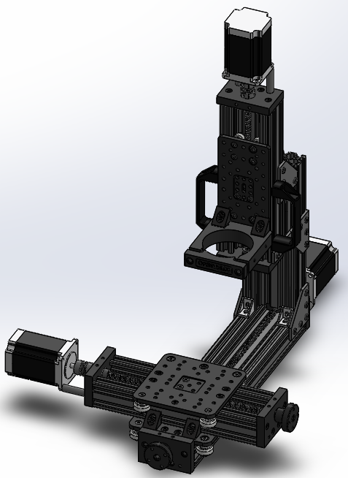

Figure 1. Finalised assembly of the 3-axis linear actuator.

1 <https://openbuilds.com/builds/openbuilds-minimill.5087/>

1. Print bed

**Timing:** 0.5h

**Materials:** Gantry plate, Aluminium collector plate, screws (M5, M4), aluminium spacers.

**Equipment:** M4, M5Allen keys.

**Critical:** Screws used to fix the Aluminium collector plate **need to be countersunk**.

Print bed consist of a gantry plate (**Figure 2/A**) and an Aluminium collector plate (**Figure 2/B**). It was designed to provide a simple collection system of MEW fibres, while offering flexibility of the design to allow for potential print bed upgrades such as different collector geometry.

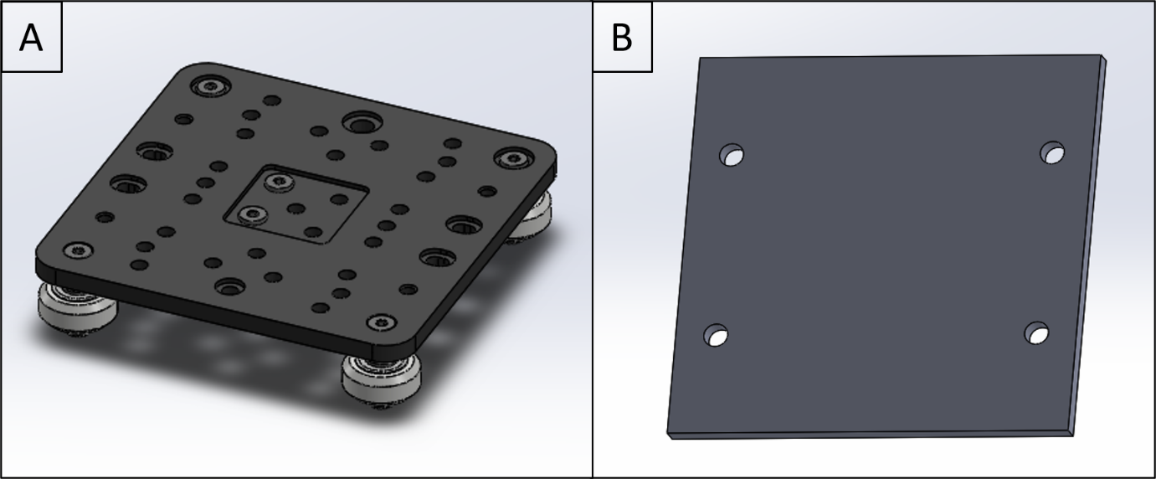

Figure 2. Print bed system consisting of **(A)** gantry cart and **(B)** Aluminium collector plate.

1. Feed four M5 screws through the dedicated holes in the Aluminium collector plate.
2. Place Aluminium spacers around the screws.
3. Mount the Aluminium collector plate onto the gantry plate using the threaded screw holes in the gantry plate.
4. Printhead

**Timing**: 1h

**Materials**: Flat head screwdriver, Kapton tape

**Critical**: Make sure the ring thermocouple is fed all the way to the bottom so it is in contact with the ring heater. Similarly, make sure the syringe thermocouple is fed half-way to the bottom through the hole.

The printhead provides storage for material used during printing process while maintaining desired material temperature via heating elements.

1. Fit syringe heater into the hollow cavity of the printhead.
2. Fit ring heater into the bottom part of the printhead.
3. Apply 2 layer of Kapton tape onto the outer part of the ring heater to protect the heating element from high voltage.
4. Fit the brass plate into the additional part of the printhead.
5. Connect the high voltage wire to the brass ring.
6. Connect both parts of the printhead together using Nylon screws.
7. Feed a K-type thermocouple through the hole as shown in Figure X.
8. Feed a K-type thermocouple half-way through the hole as shown in Figure X.
9. Place a syringe inside the printhead so that the nozzle pokes through a hole in the ring heater outside the printhead.
10. Bend the wiring and use a clamp arrangement to lock the syringe insider the printhead and keep the electrical connections secured.

Take actual pictures of the printhead assembly.

1. Framework

**Timing:** 3h

**Materials:** Corner brackets, 30x30 aluminium profiles, 20x20 aluminium profiles, 20x80 aluminium profiles, M5 hammer nuts and M6 nuts, latching magnets**,** door handles, laser cut parts.

**Equipment:** M6 and M5 Allen keys, spirit level.

**Critical:** Make sure that corner brackets are flash with the adjacent panels to achieve solid and robust construction.

Framework consists of 30x30mm and 20x20 aluminium extrusion profiles connected together using corner brackets. Top section consists of sensors and actuators mounted directly to the framework, while the bottom section consists of electrical components assembled on an Aluminium plate and two gantry plates.

1. Connect the base of a frame using six 850mm and two 680mm 30x30 aluminium profiles (**Figure1/A**).
2. Follow OpenBuilds instructions1 to assemble two gantry carts.
3. Use four 80x20 profiles to fit two gantry carts from step 2)
4. Use a 30x30 profile and to complete the base of the frame (**Figure1/B**).
5. Attach nine 30x30 profiles (**Figure1/C**).
6. Attach linear stages system developed in 1).
7. Attach four 20x20 profiles (**Figure1/D**).
8. Construct and attach vision system support. INCLUDING RAIL FOR LED
9. Use eight 30x30 profiles, hinges and door handles to construct a pair of doors.
10. Attach the door to the frame (**Figure1/E**).
11. Use four 30x30x profiles to finish the top part for the framework (**Figure1/F**).
12. Use an acrylic panel, hinges and a door handle to construct electrical door.
13. Attach four pairs of magnets to construct latches for the electrical and main door.
14. Attach silicone bumpers on the inside of the electrical door (OPTIONAL)

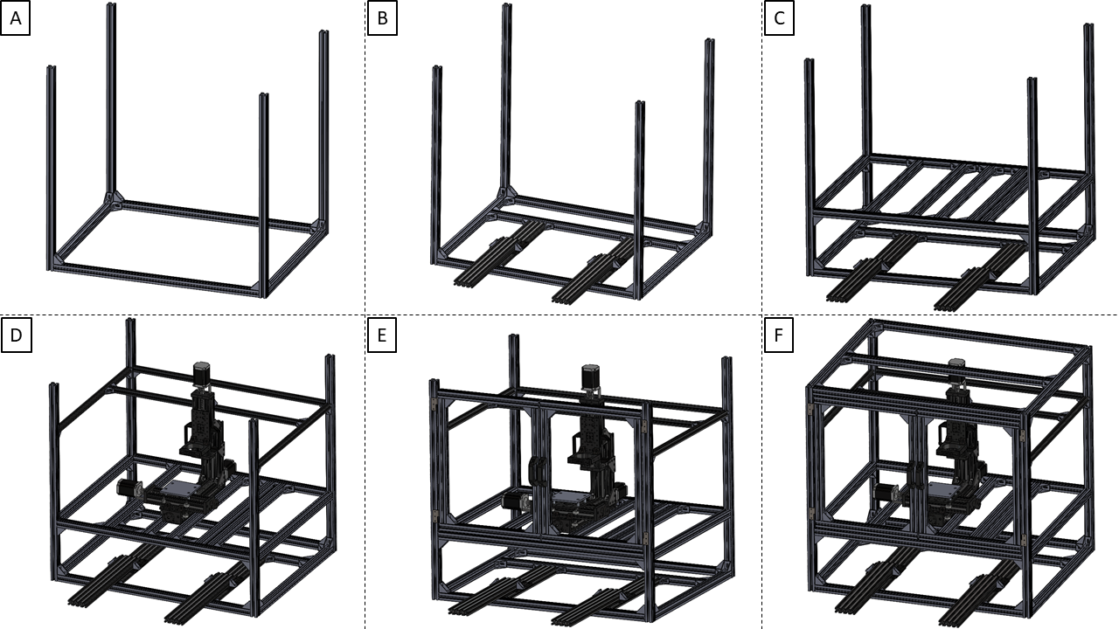

Figure 3. Framework assembly process includes assembly of **(A)** a base frame with **(B)** sliding gantry system of **(C)** electrical section, **(D)** printing section with linear actuators, **(E)** printing section access door and **(F)** complete framework.

1. Final step

**Timing:** 3h

**Materials:** Printhead, printhead clamp, pressure regulator, pressure sensor, high voltage unit, thermocouple and thermocouple connectors, camera, lens, lens clamp, non-contact magnetic switches, laser cut acrylic panels.

**Equipment:** M5 Allen key,

**Critical:**

In the last step we finalise mechanical assembly by mounting a print bed, printhead, electrical components and acrylic panels.

1. Place the printhead in the dedicated head holder.
2. Attach the printhead using a custom-made replacement clamp.
3. Attach pressure regulator.
4. Attach pressure sensor.
5. Attach high voltage power supply.
6. Attach thermocouple connections.
7. Mount monitoring system.
8. Attach a non-contact safety switch on both doors.
9. Attach top acrylic panels.
10. Attach back acrylic panels.
11. Attach left side acrylic panels.
12. Attach right size acrylic panels.
13. Attach front door acrylic panels.
14. Attach front electrical drawer acrylic panels.

Missing acrylic panels